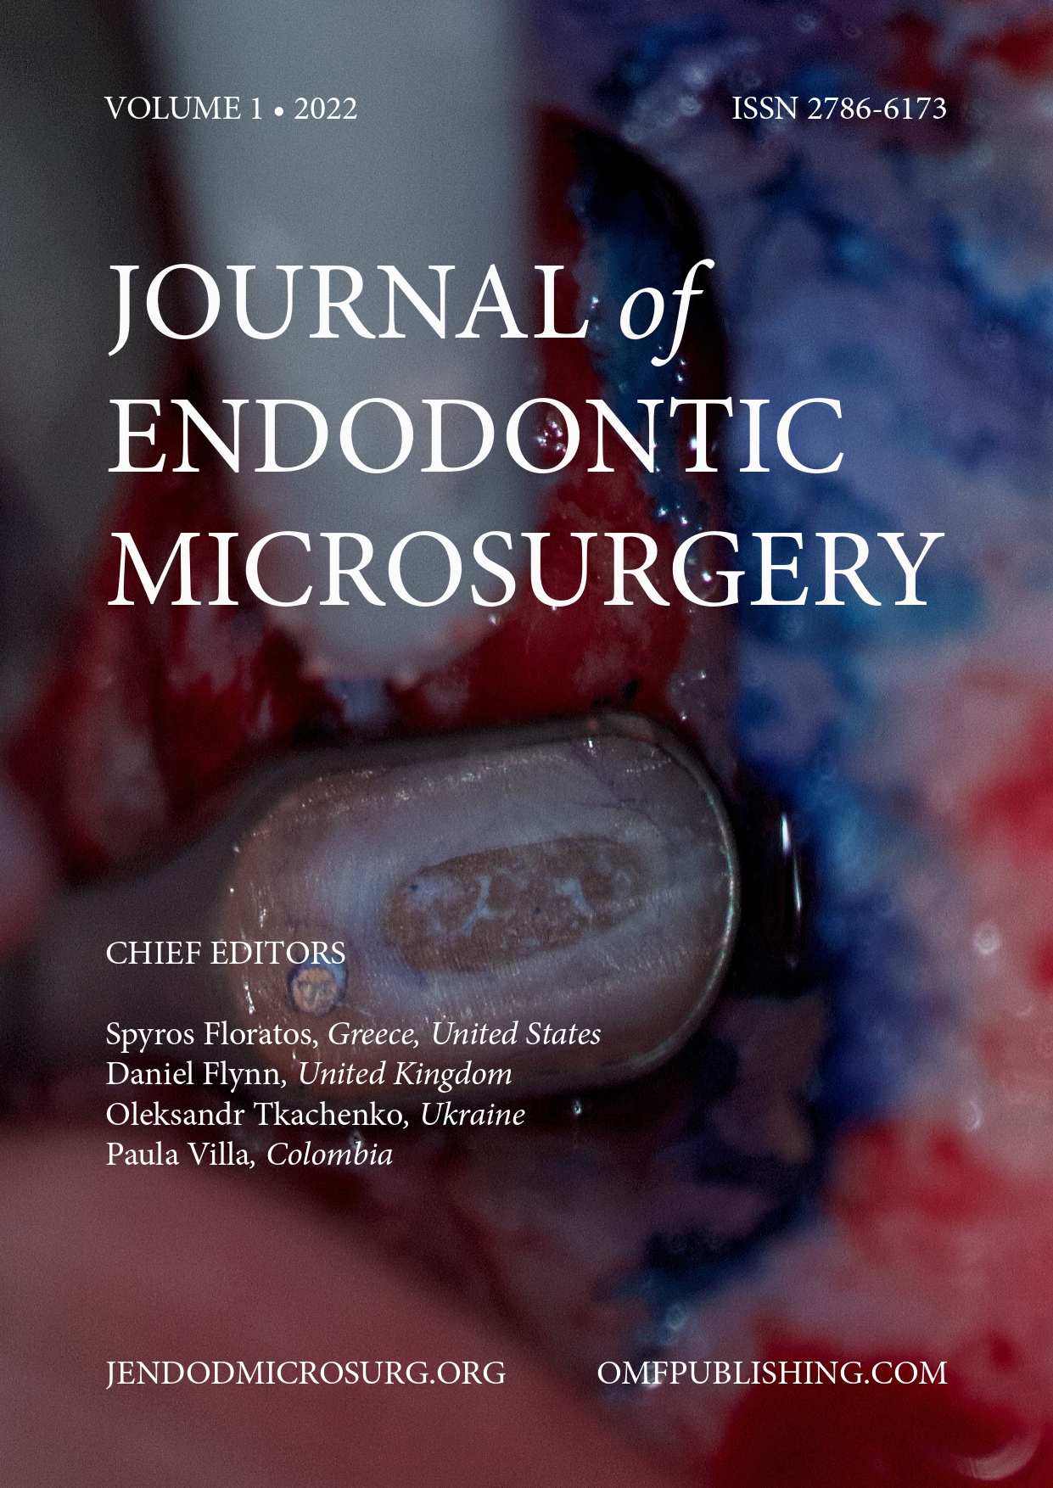 | Cover Letter  June 08, 2022  Editors of Journal of Endodontic Microsurgery

Dear Editors of Journal of Endodontic Microsurgery,

We are submitting a manuscript for consideration of publication in Journal of Endodontic Microsurgery. The manuscript is entitled “Trabecular Juvenile Ossifyng Fibroma Management by Virtual Surgical Planning, Piezoelectric Surgery and Simultaneous PSI Reconstruction. Case Report.” It has not been published elsewhere and that it has not been submitted simultaneously for publication elsewhere.
Trabecular juvenile ossifying fibroma is a rare fibro-osseous lesion affecting the craniofacial skeleton occurring commonly in children and young adults. Tumor clinical behavior is highly aggressive with invasion of adjacent anatomic structures. Because of its high recurrence rate complete excision is necessary, but this one could be facial mutilating. This case report presents a 23-year-old female patient with a trabecular juvenile ossifying fibroma of the right maxilla, expanding into the orbit and zygomatic bone. The report also shows the multidisciplinary surgical management of this lesion with successful preservation of optic nerve function and facial aesthetics.

Thank you very much for your consideration.

Sincerely Yours,
John Stones and colleagues

Department of Oral and Maxillofacial Surgery,
Colombia University Clinic,
International Sanitas Organization
23rd Street, 66-46, Bogotá D.C. Colombia
Tel.: + (571) 325 51 28
E-mail: …..@.....

